**Sound Module Implementation**

This module is strictly FMOD based sounds implementation. You can not use this implementation for Unity Audio System.

**Versions Used:**

* Unity 2019.4.14 f1 and above
* FMOD version 2.01

**Architecture:**

* Scriptable Object Architecture

**Scripts:**

* 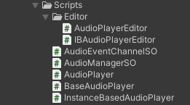BaseAudioPlayer.cs
* AudioPlayer.cs
* InstanceBasedAudioPlayer.cs
* AudioManagerSO.cs
* AudioEventChannelSO.cs
* AudioPlayerEditor.cs

**Channels (Scriptable Objects):**

* 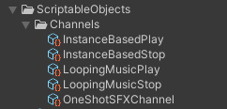OneShotChannel
* LoopingMusicPlay
* LoopingMusicStop
* InstanceBasedPlay
* InstanceBasedStop

**Manager (Scriptable Object):**

* AudioManager

**How It Works:**

So the basic flow is that AudioEventChannelSO.cs event is called from AudioPlayer.cs or InstanceBasedAudioPlayer.cs. As AudioManager.cs is an scriptable object it will subscribe different AudioEventChannelSO.cs events on scene start. When Event will be called the desired audio will be played.

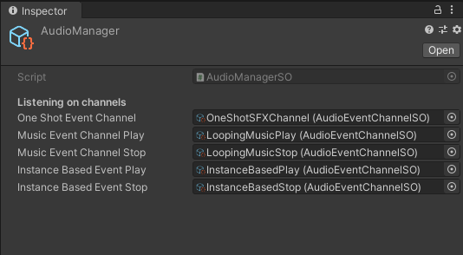AudioManager should have reference to all audio channels.

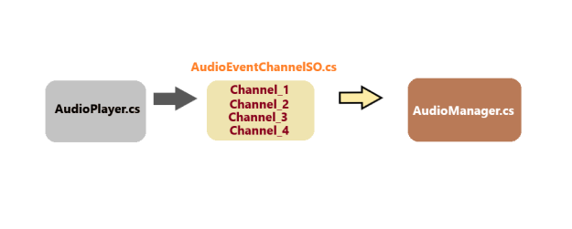

**How To Use:**

Implementation of these audios can be categorized to three types.

* Oneshot Audio clips
* Looping Audio clips
* Instance based Audio Clips

To play simple OneShot or Looping Audio we have to place a gameobject having AudioPlayer component in scene with information of channel and audio event as shown in figure:

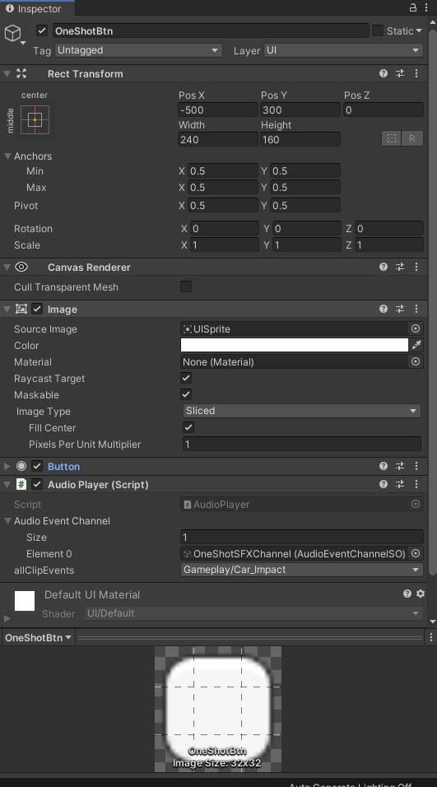



Now we can either make a button to call specific function to shoot events or write a new script to call AudioPlayer.cs public functions to shoot specific events.

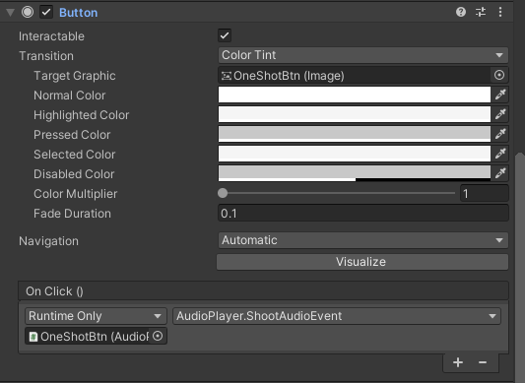

Both oneShot and looping sounds can be triggered through ShootAudioEvent function.

For instance based sound we use two audio channels at the same time so we have bit different implementation of instance based audios. We have two specific functions for instance based audios PlayInstanceAudio() and StopInstanceAudio(). Script Used for this purpose is InstanceBasedAudioPlayer.cs

Implementation of instance based sound is shown in figure below:

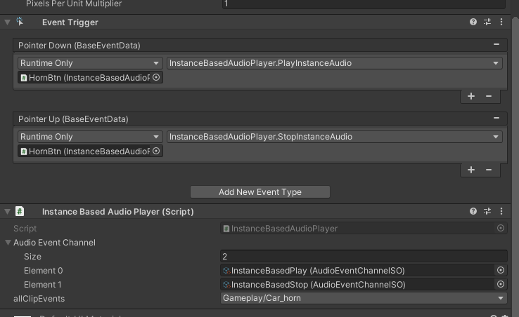

**That’s All**

Any **Questions** or **Feedback**?

Feel free to contact **developer** :D

!!muhammadumar@theknights.com.pk!!